A000-Asia-China-Bronze-Gui-Kuei-Shang-1800 BCE

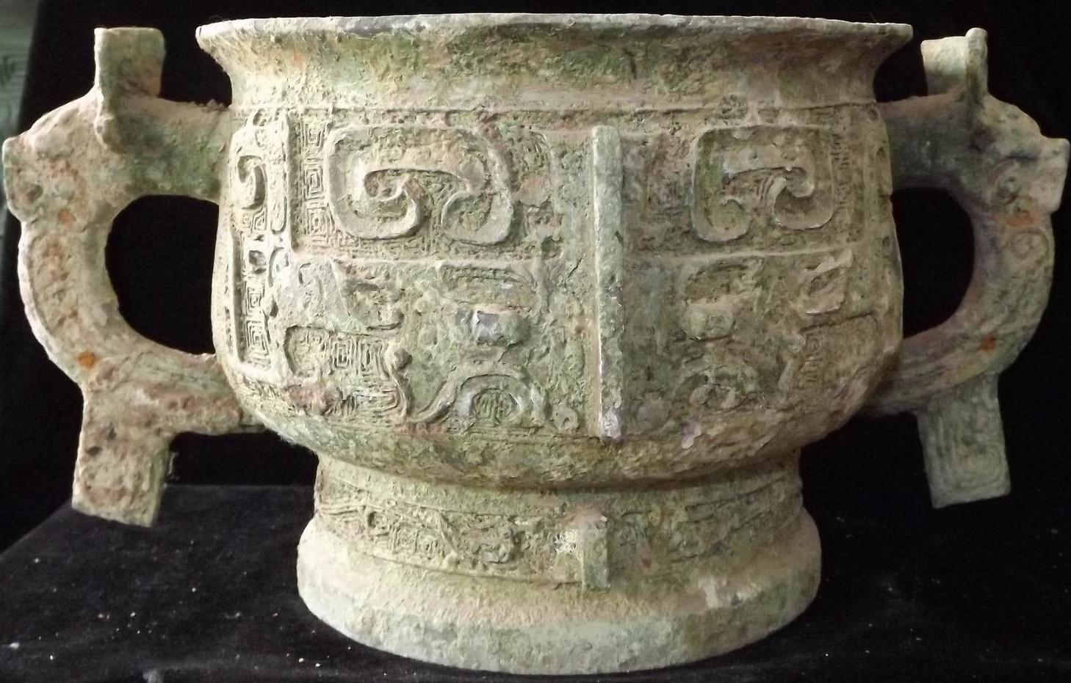

Case No.: 5 (Counter Display)

Accession No.

Formal Label: Asia-China-Bronze-Gui-Kuei-Shang-1800 BCE

**Display Description:**

Gui-Kuei (WG) was a Shang period wide-mouthed lidded bronze food container with a ring base and an ample, bowl-shaped body with slightly rounded sides. The gui shape first appeared in Neolithic Period (c. 3000–2000 BCE) pottery. By the middle of the Western Zhou dynasty this form was widely used but by the end of the Zhou period, the gui was only used as a funerary utensil. Stone and jade gui, probably used in a ritual capacity, were found at Yinxu. Yinxu  (殷墟: "Ruins of Yin") is the last capital of China's Shang dynasty. In this location were found oxen scapulae on which were written a script (called by the locals “oracle bones”) that was the earliest known Chinese writing.

L**C Classification:** NK7983.

Date or Time Horizon: 1800 BCE

Geographical Area: possibly Yinxu

**Map:**

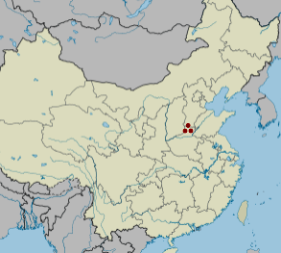

**GPS coordinates:** [36°08′22″N 114°18′11″E](https://tools.wmflabs.org/geohack/geohack.php?pagename=Yinxu&params=36_08_22_N_114_18_11_E_type:landmark)

Cultural Affiliation: Shang

Medium: Bronze

Dimensions:

Weight:

Condition:

Provenance:

**Discussion:**

In the bronze art of the Shang dynasty, the gui commonly had four lugs (ear-shaped protuberances) equally spaced on a decorative band just below the rim. As the shape developed in the Zhou dynasty, the lugs were replaced by two or four sturdy handles, often modeled with fanciful animal motifs. A substantial, boxlike stand often anchored the vessel in examples from the Zhou period.

**References:**

References:

d'Argencé, René-Yvon Lefebvre. 1967. Bronze vessels of ancient China in the Avery Brundage Collection. San Francisco: Asian Art Museum of San Francisco. [Berkeley, Calif.]: Published by Diablo Press for the De Young Museum Society. A comparable example is in the Avery Brundage Collection ( d'Argencé 1967:34-35, no. IX).

Appendix:

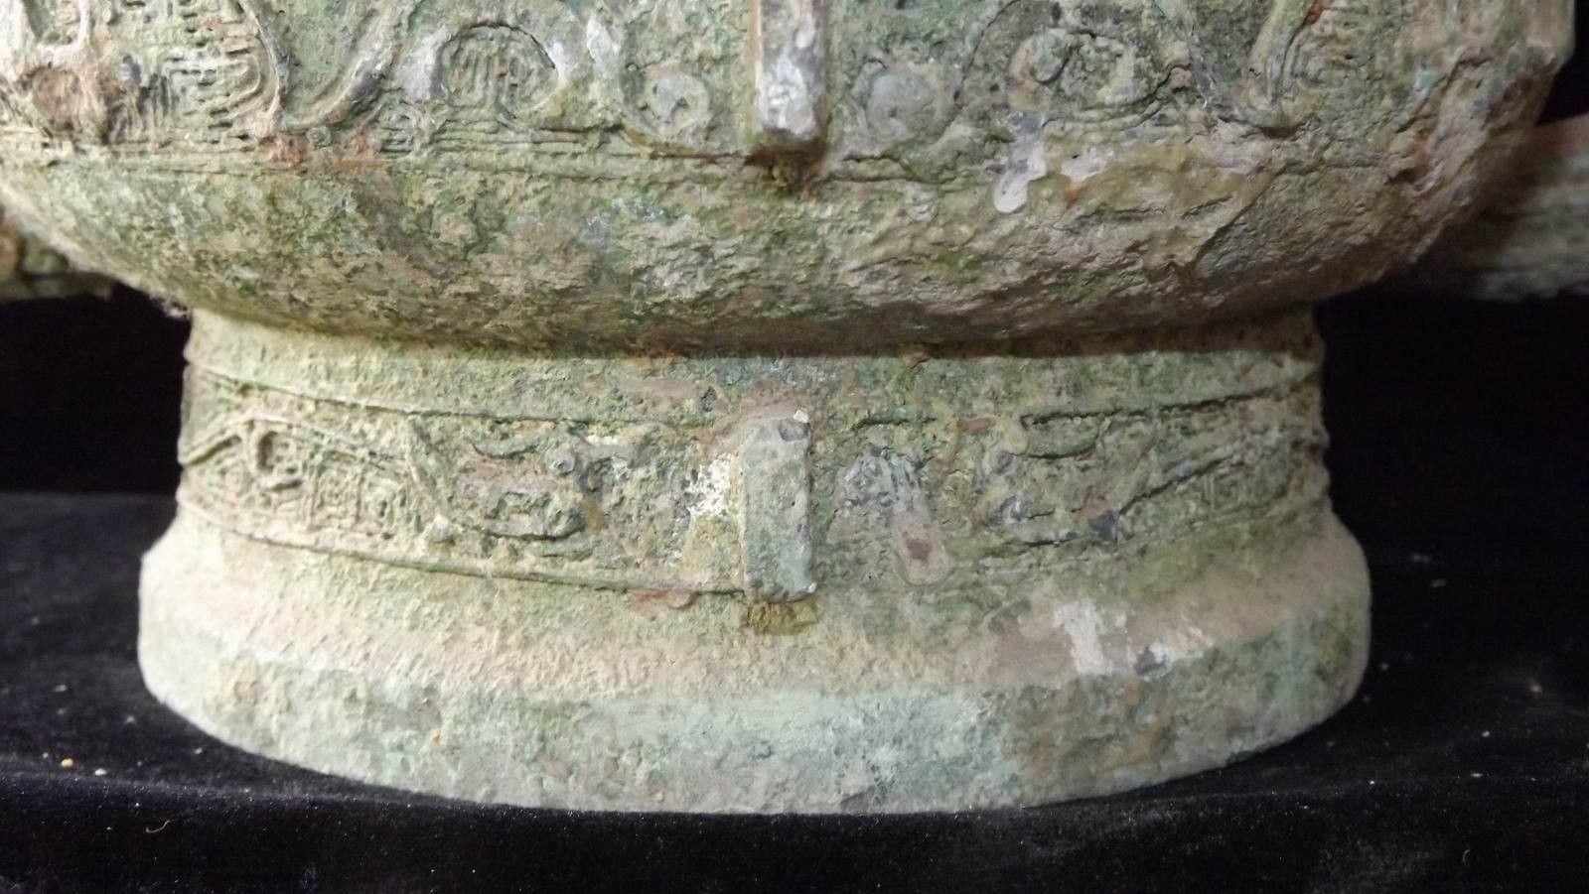

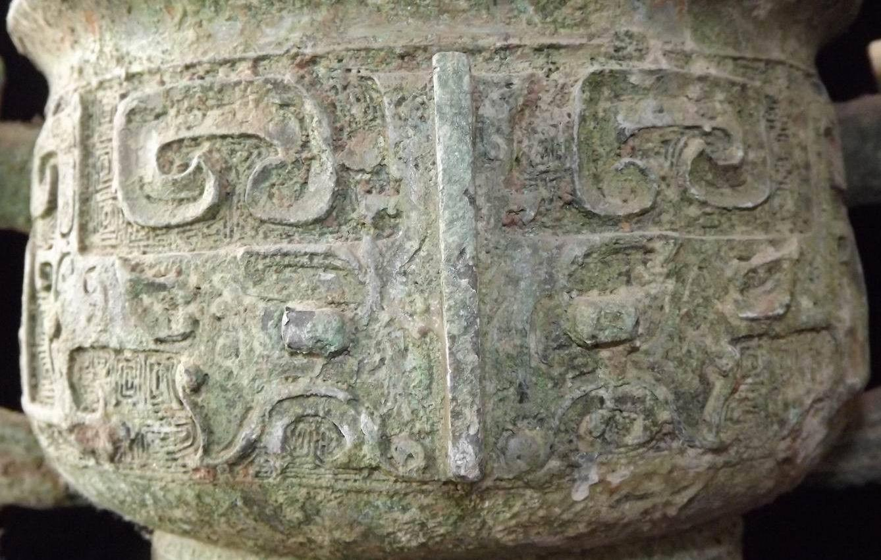

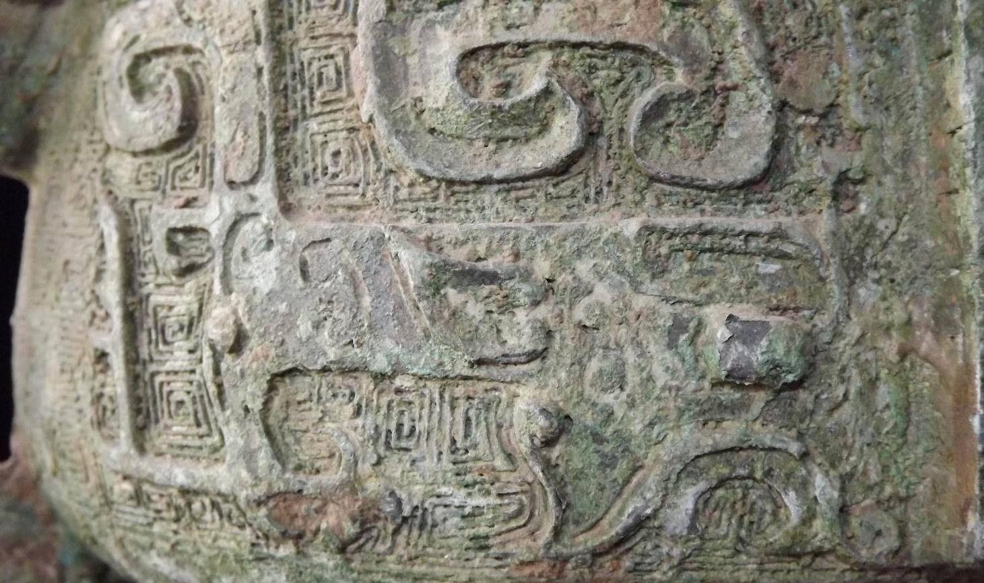 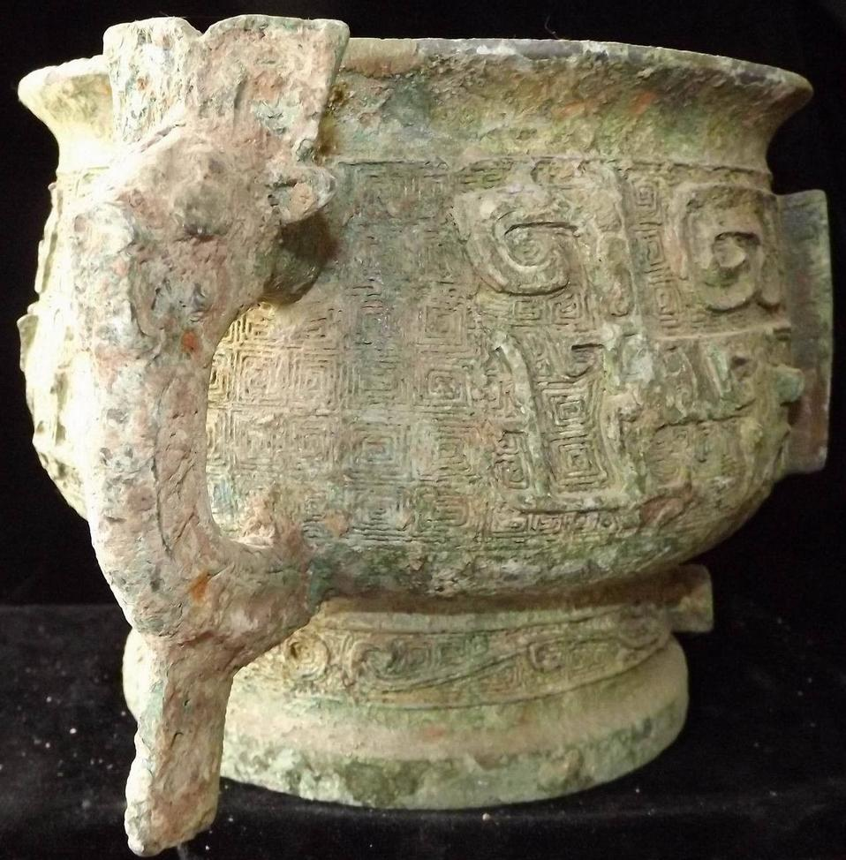 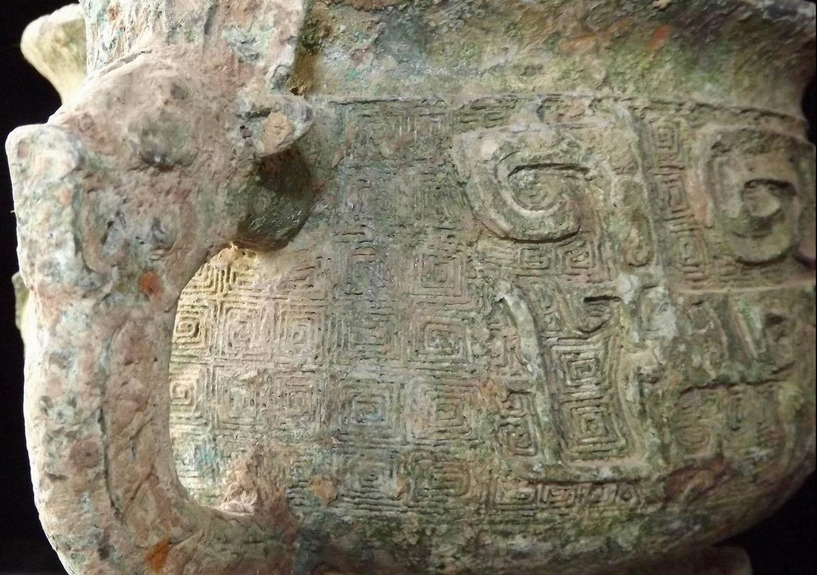 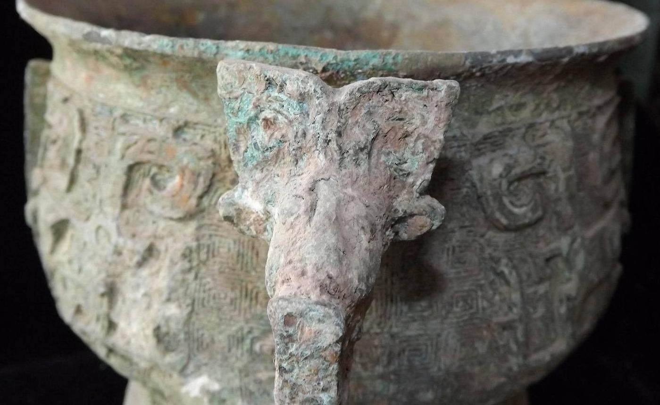 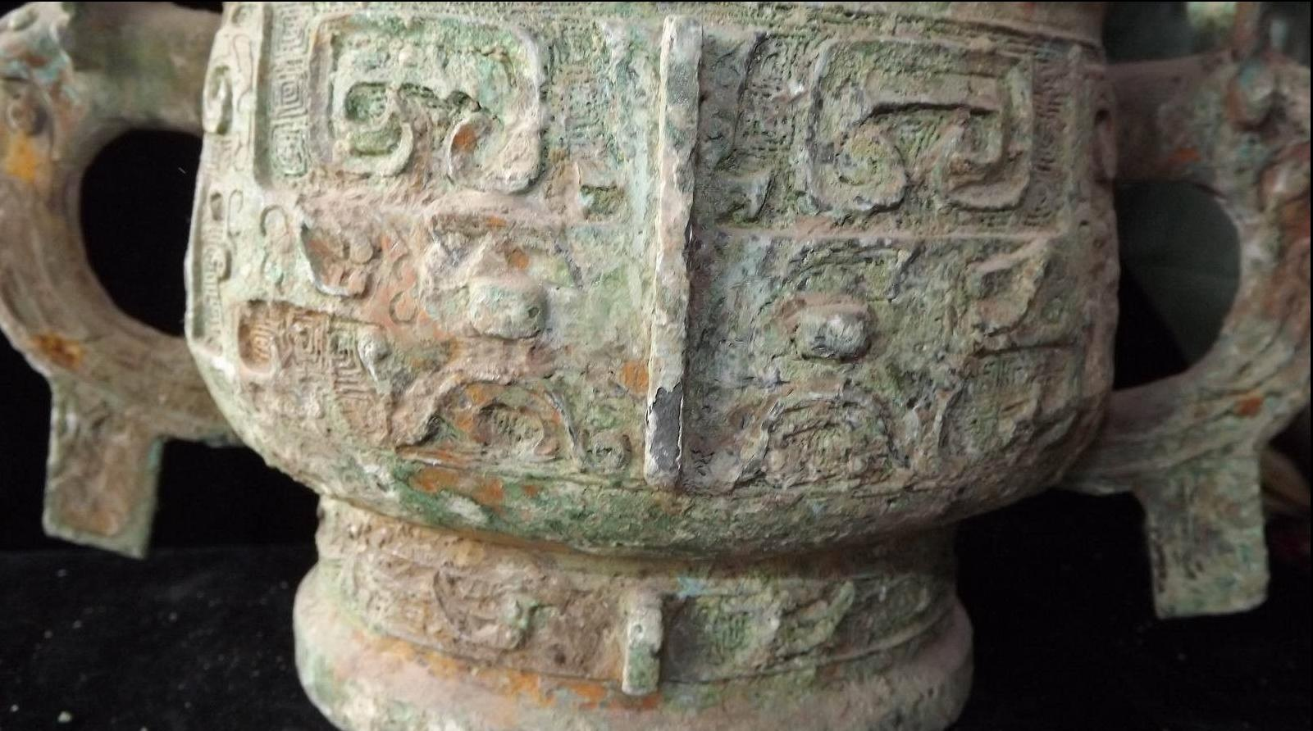 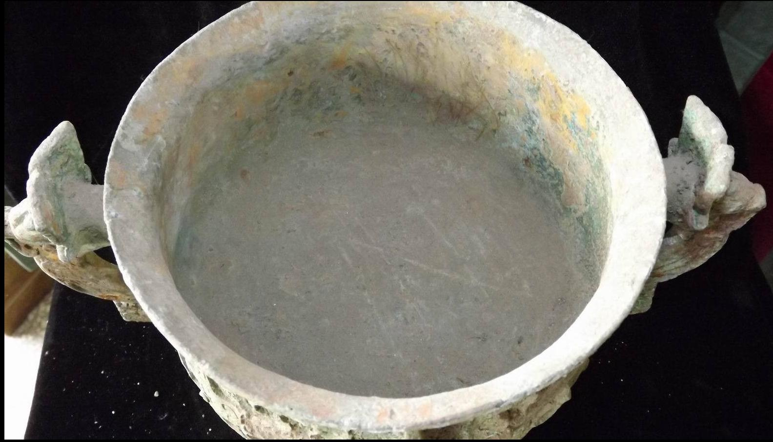 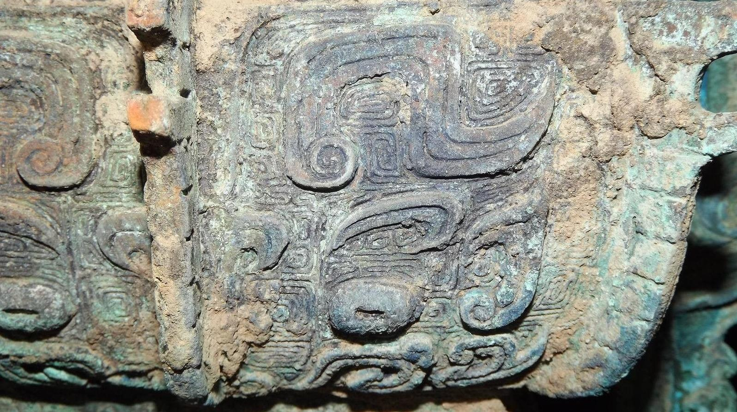 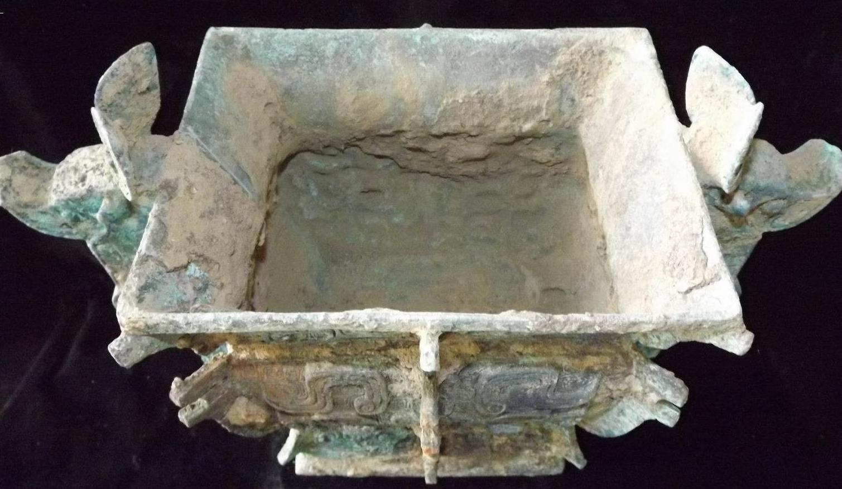 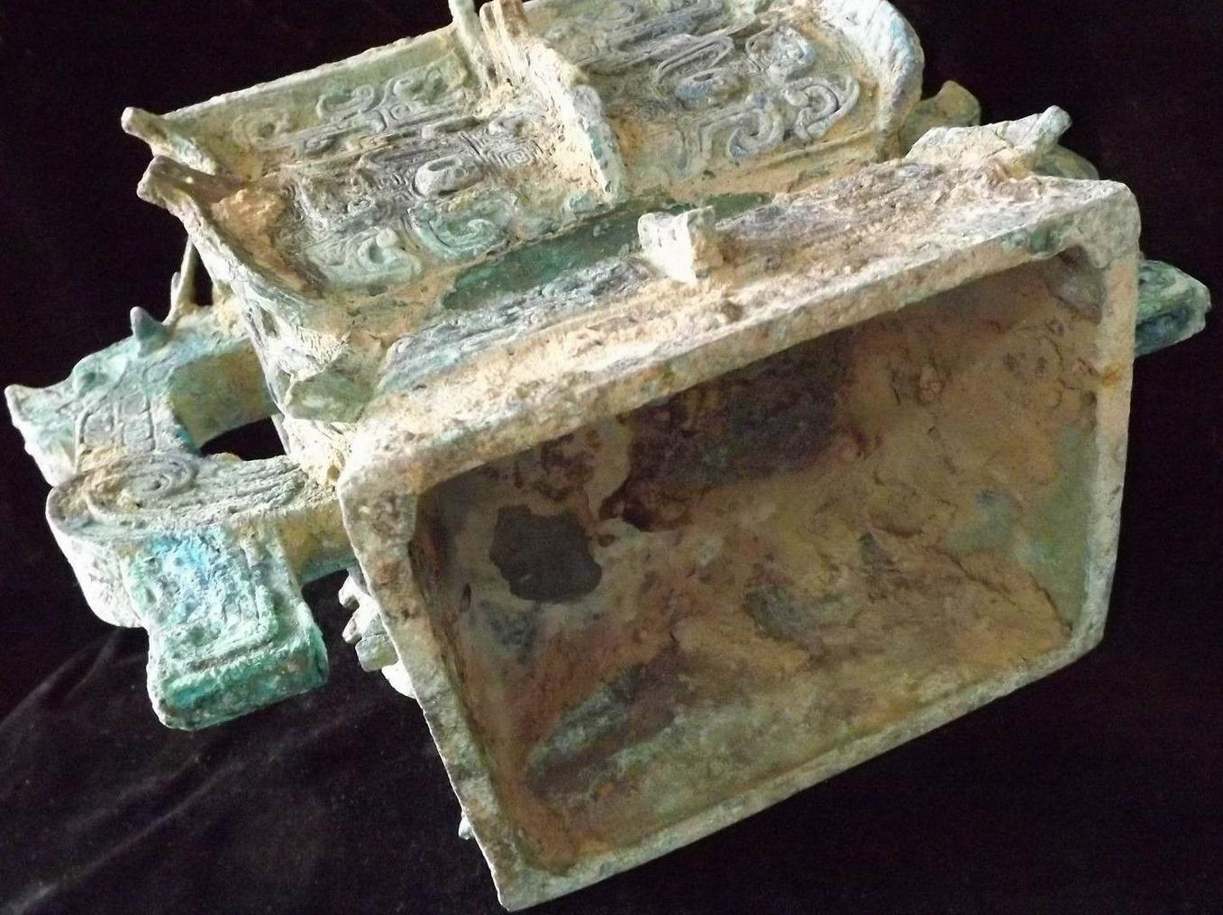

Case No.:

Accession No.

Formal Label:

**Display Description:**

Accession Number:

**LC Classification:**

Date or Time Horizon:

Geographical Area:

**Map:**

**GPS coordinates:**

Cultural Affiliation:

Media:

Dimensions:

Weight:

Condition:

Provenance:

**Discussion:**

**References:**